An on-demand services marketplace inspired by inDrive's way of connecting customers with providers, negotiating offers, communicating in-app and building trust. The difference is that Findit handles services, not rides, and its architecture should support expansion into other markets later.
Here's the corrected business concept and flow.

Findit Harare — Business Concept
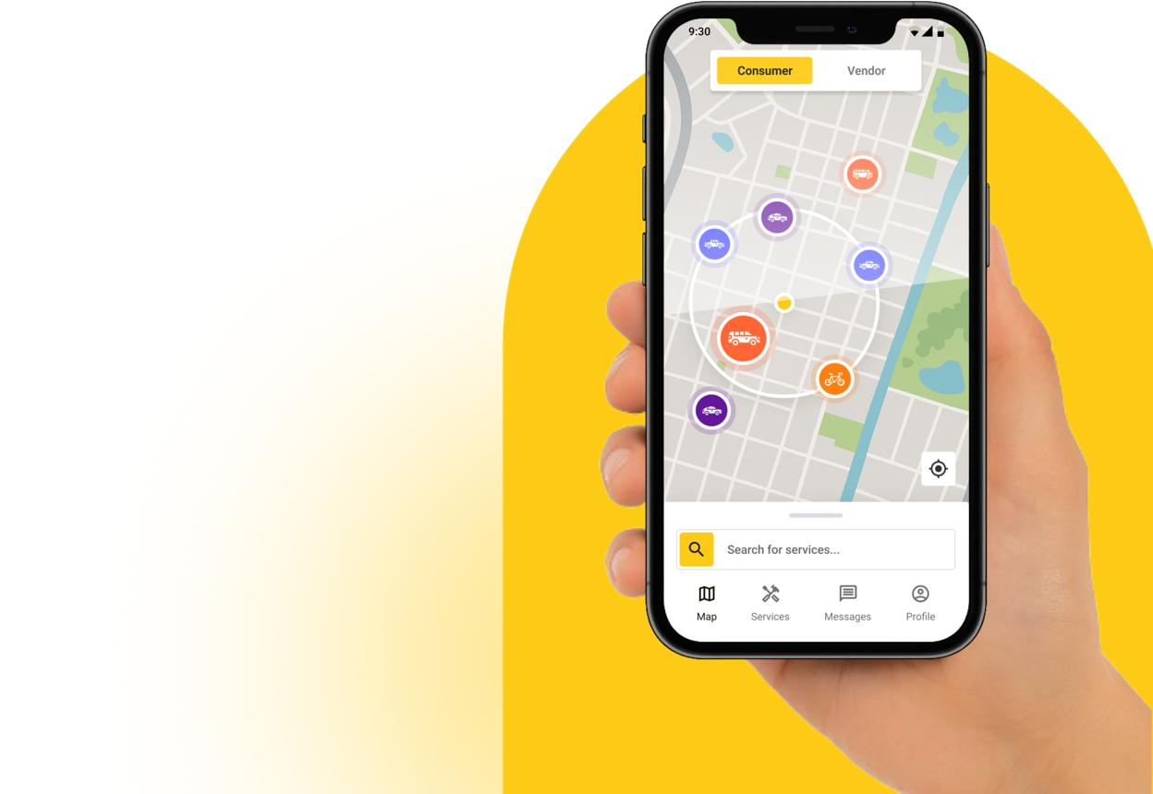
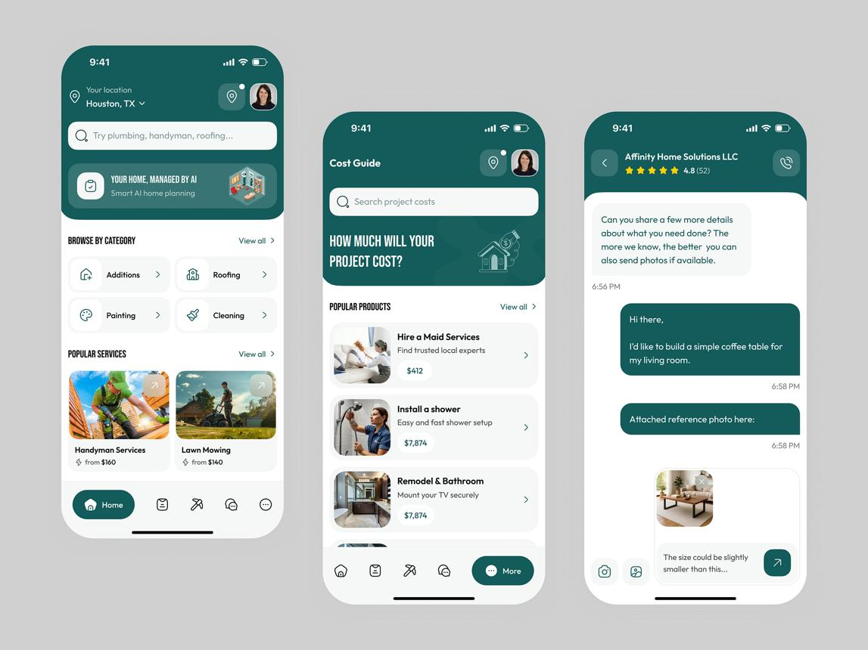
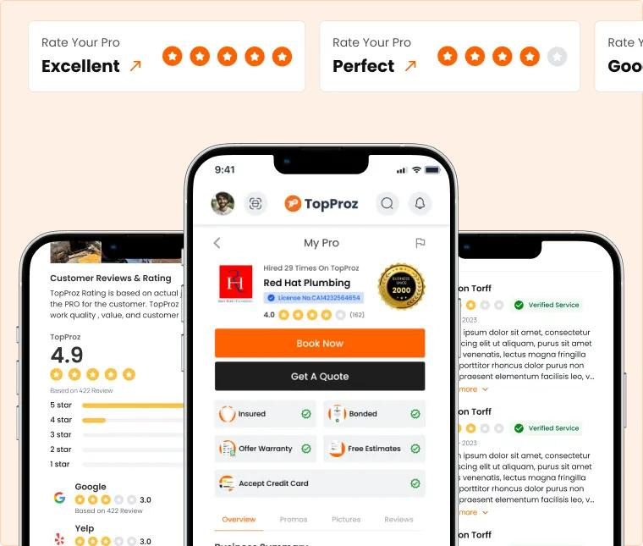
15

1. The core idea
Findit Harare is a service marketplace where customers can request services, receive offers from available providers, compare their options, negotiate where appropriate, communicate through in-app chat or calls, and confirm a provider.
For example, a customer needs someone to braid their hair at home. They create a request with the hairstyle, preferred time, location and budget. Available braiders can respond with offers. The customer compares prices, ratings, distance and portfolios, chats with providers and accepts the most suitable offer.
The platform can eventually support many other services, from beauty and grooming to repairs, cleaning, delivery and other everyday needs.

2. How the inDrive-inspired model works
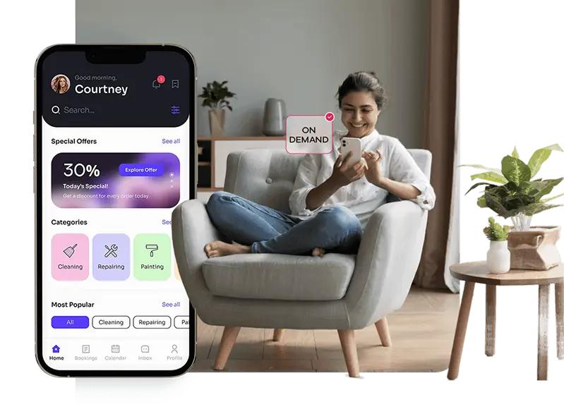
1. Customer requests a service
The customer selects a category, describes what they need, adds photos if relevant, chooses a preferred time and location, and suggests a budget or price.

2. Providers find the request and make offers
Eligible providers can discover relevant requests and submit their proposed price, availability and any additional costs. Customers can compare multiple offers.
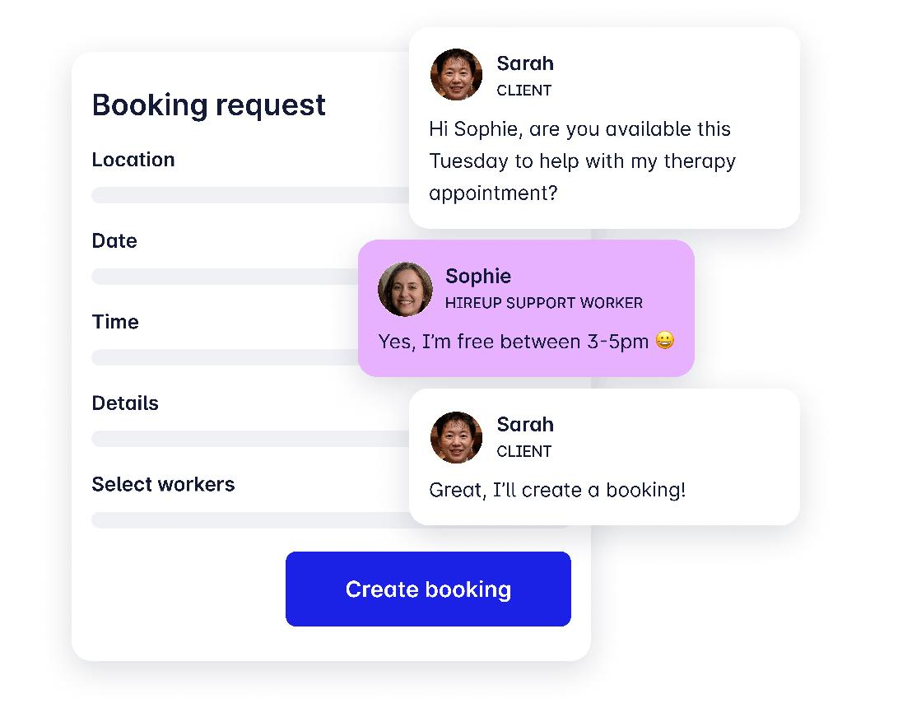
3. Customer and provider communicate
They can use in-app chat and, where supported, in-app voice calls to clarify the service, price, location and timing. Contact details should be handled with appropriate privacy controls.
4. Customer reviews the provider and accepts an offer
The customer can check ratings, reviews, portfolio, verification status, price and estimated distance before accepting. Acceptance creates a confirmed service booking, subject to the agreed terms.
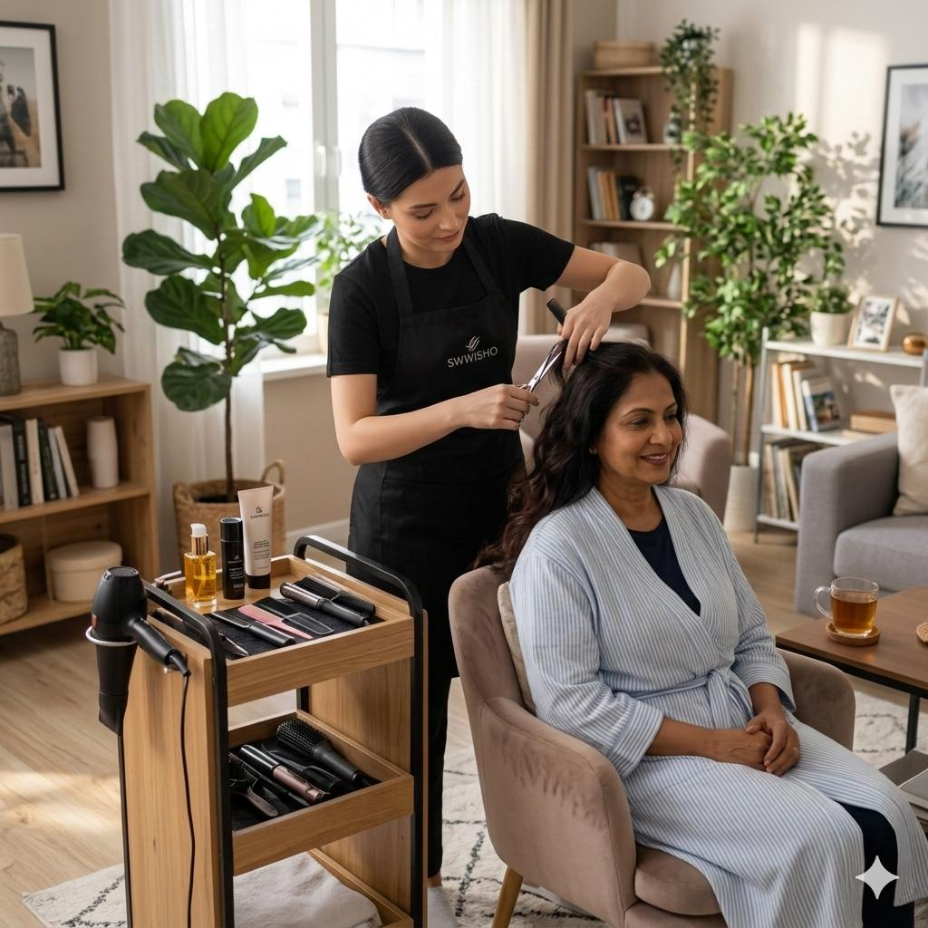
5. Service is completed and rated
Both sides can update the booking status. After completion, the customer can rate and review the provider, and the provider can optionally rate the customer. Ratings should be tied to genuine bookings.

3. The major features
Feature | How Findit should use it
Find Offers | Customers post service requests; providers send offers, and customers compare them.
In-app chat | Customers and providers discuss requirements without immediately leaving the platform.
In-app calls | Support calls between matched parties, ideally with privacy-protecting call options where technically feasible.
Interactive map | Show relevant providers or service requests by approximate location, service area and availability.
Provider profiles | Display services, portfolio, prices, service areas, experience and availability.
Ratings and reviews | Build reputation using reviews connected to completed bookings.
Profile verification | Support phone verification and, where appropriate, additional identity or business checks. Clearly explain what each badge means.
Booking management | Track requests, offers, accepted bookings, cancellations and completion.
Notifications | Alert users about new offers, messages, accepted bookings, schedule changes and other relevant events.
Admin dashboard | Manage users, listings, verification, reports, disputes, reviews and platform activity.
Future monetisation | Support suitable service fees, provider subscriptions, promoted listings or commissions once the model is validated.

4. How the map should work
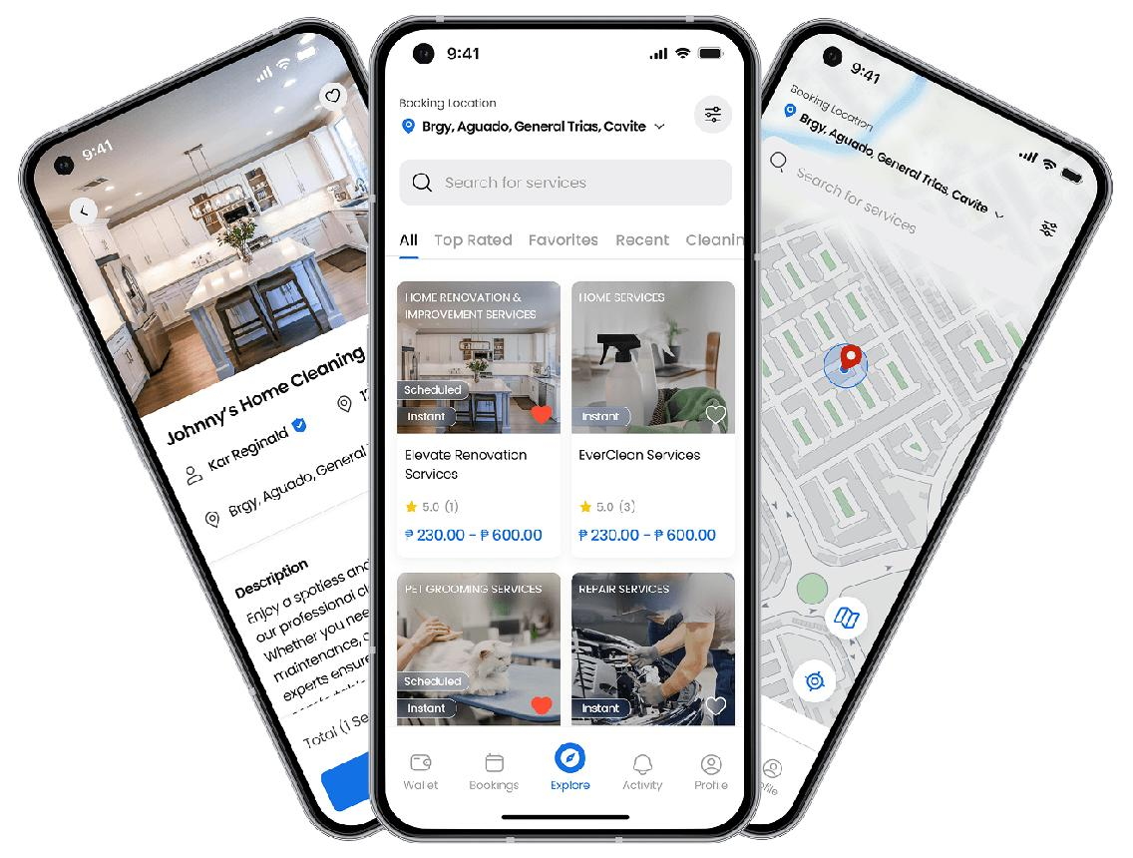
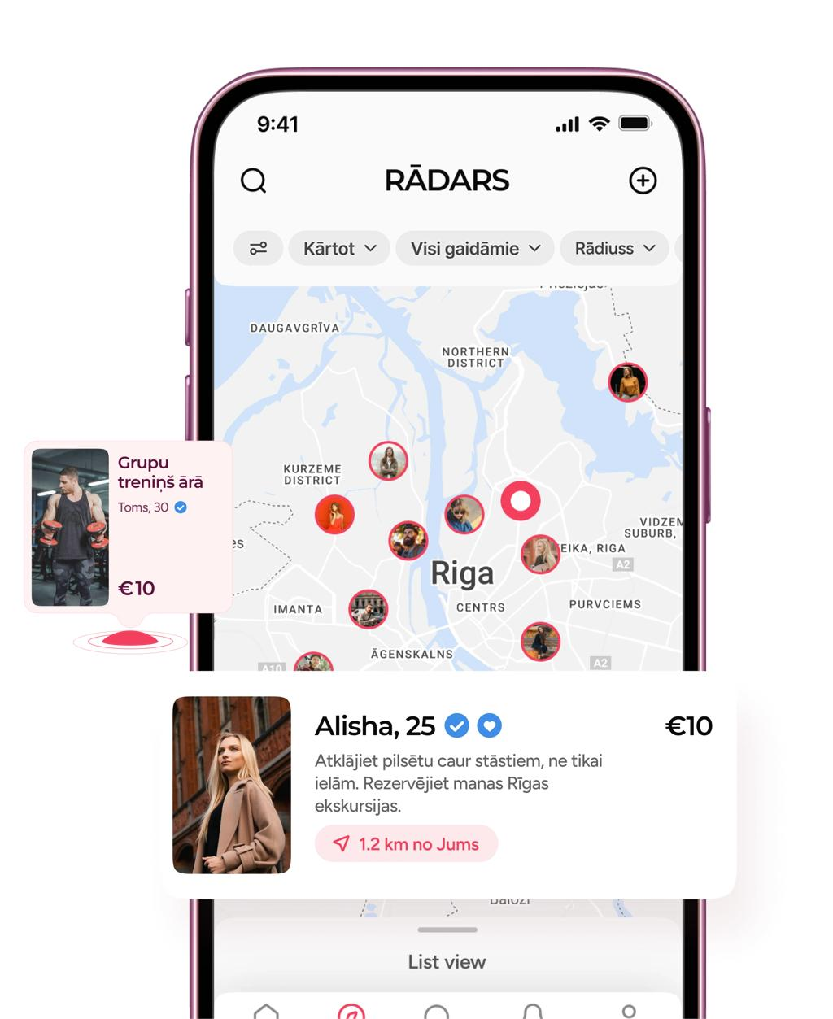
10
The map should be functional, not decorative.
- Customers can set the service location or select it on a map.
- Providers can set the areas they serve.
- The app can show relevant providers or requests based on location and service category.
- Customers can compare provider distance, availability and offers.
- Providers can find suitable nearby requests.
- Exact home addresses should only be shared when needed for an accepted booking and according to the platform's privacy rules.
Because Findit covers many types of services, it should not force every category to use the same location logic. A mobile braider may travel to a customer, while a customer visiting a nail salon may travel to the provider. A remote service might not need a map at all.

5. The Find Offers system
This is one of the most important parts of the platform.
The process should support two ways to start a transaction:
Option A — Customer posts a request. The customer describes the job and can suggest a budget. Relevant providers submit offers with their prices and availability.
Option B — Customer finds a provider. The customer opens a profile, checks the provider's services and sends a booking request or negotiates through chat.
Both flows should lead into the same booking system so that messages, accepted prices, status updates, reviews and dispute records remain connected.
The app should make clear whether an offer is merely a proposal, whether the customer has accepted it, and whether the provider has confirmed the appointment. It should also define what happens when an offer expires, either side cancels or the customer changes the requirements.

6. Verification, trust and ratings
Findit should provide several levels of trust rather than displaying a generic “verified” badge without explanation.
- Phone verified: the user confirmed control of a phone number.
- Identity checked: identity was checked using an appropriate process.
- Business verified: relevant business details were checked, where applicable.
- Customer rating: feedback from genuine completed bookings.
Only show the checks actually performed. Verification is not a guarantee that a person will provide a good service or that every interaction is risk-free.
The platform should also have reporting, blocking, cancellation policies and a process for handling complaints and disputed bookings.

7. The business model
The marketplace should first prove that it can connect customers with providers successfully.
Possible revenue streams later include:
- A commission or service fee on completed bookings.
- Paid provider subscriptions for useful business features.
- Clearly labelled promoted offers or provider listings.
- Business accounts for larger service providers.
- Additional category-specific services as the platform expands.
For the first pilot, focus on attracting reliable providers and completing successful bookings. Avoid adding payment complexity before you know what customers and providers actually need.

8. The technology strategy
Bro, one important point: build Findit as its own product, not as a copy of inDrive. Borrow the useful marketplace mechanics, but create a system designed for many service categories.
The core system should separate:
- Users, roles and verification.
- Service categories and provider profiles.
- Service requests and offers.
- Chat and call sessions.
- Maps, service areas and location permissions.
- Bookings and status transitions.
- Ratings, reviews and reports.
- Notifications and admin controls.
- Payments and monetisation, added when appropriate.
This will make it easier to add new categories without rebuilding the whole application.
The chat, offers, booking status and notifications must share the same backend records. For example, accepting an offer should update the booking and notify both parties, rather than just changing a button on one screen.

9. Product flowchart
Customer or provider opens Findit
Customer
Find a provider or post a request
Provider
Browse relevant requests or receive enquiries
Request and offer matching
Service, price, availability and location
Compare, chat and call
Clarify details and negotiate where appropriate
Accept offer and confirm booking
Service delivered and booking completed
Ratings, reviews and reputation

10. Recommended rollout
Do not attempt to launch every feature and every category at once.
- Phase 1 — Validate: Start with beauty services in selected Harare areas and test requests, offers, profiles and successful bookings.
- Phase 2 — Strengthen: Improve chat, notifications, maps, verification, reviews, cancellations and admin tools based on real usage.
- Phase 3 — Monetise: Test suitable fees or subscriptions once the platform consistently delivers value.
- Phase 4 — Expand: Add grooming, home services and other categories, with category-specific booking and location rules.
- Phase 5 — Scale: Improve operational support, security, analytics and payments as demand grows.
The first phase should still be a genuine working marketplace, not a demo. You can keep the launch area and number of categories small without pretending the essential features work when they do not.
My recommendation, bro: Make Findit Harare a request-and-offer marketplace with in-app communication, not just a directory. Start with beauty to establish the first market, but design the core system around the larger vision: one place where people can find, compare, negotiate and book services.

